Spring 2020 MKT 3350 Introduction to Marketing

Section 1

Class: MWF, 10-10.50 am Rawls room 101
Instructor: Dr. Jeffrey Harper
Office: W 352
E-Mail: Jeffrey.Harper@ttu.edu
Phone: 834-2028
Web Page: http://harper.ba.ttu.edu
Textbook: Marketing-grewal/levy 7th edition

Book registration: Register on Blackboard. See last page of this document
PollAnywhereRegistration:
https://PollEv.com/jeffreyharpe796/register?group_key=zZh6LbCZGWFEjkEZuhlWHoSmQ

Jharpermkting

Office Hours: MWF 8-9 am and by appointment

Course Objectives:
The primary purpose of this course is to provide an overview of the discipline of marketing, both as a philosophy of business and as a series of business practices.

The course will explore the field of marketing, as it directs the organization’s resources to satisfy customers’ wants and needs through the exchange process, at a reasonable profit to the organization. Specifically, we will examine how marketers: understand consumers’ needs and wants; develop products and services that provide superior value; and how they price, distribute, and promote products and services effectively, both domestically and internationally.

The course will direct your study of the organization (either a profit-oriented firm or a non-profit organization) as a market entity existing in a competitive environment. The emphasis will be on understanding the importance of quality, value, and customer relationship management in obtaining a competitive advantage in today’s marketplace. In addition, we will consider the ethical and societal issues related to marketing.

Teaching Methods:
The course builds upon a variety of pedagogical techniques including lecturing, in-class discussions, and active-learning exercises.
Recommended reading not required but great for personal growth & results achievement:
Mark Devine’s “Unbeatable Mind”

Name Tags: Please bring a name tag that I can read from a distance and that you will display on your desk and bring to class every day that has the following information:
Your Name
Major
Hometown

Expected Learning Outcomes:
Upon successful completion of this course, students should develop:

- The ability to identify marketing mix elements.
- The ability to analyze marketing strategy formulation and implementation.
- The ability to describe customer centric organizations
- The ability to apply marketing concepts and strategies to offer sound solutions to real world marketing problems
- The ability to demonstrate higher order thinking and critical thinking
- The ability to realize ethical dilemmas in marketing and apply decision marketing tools
- The ability to work in teams
- The ability to use concepts to persuasively communicate suggested solutions to marketing problems
- The ability to apply marketing concepts to marketing one’s self

Option 1. Means of Assessment of Learning Outcomes without final:
Exam # 1 (25 %) 100 points
Exam # 2 (25 %) 100 points
Exam # 3 (25 %) 100 points
Chapter Quizzes & 2 simulations (25%) 100 points

If class meets attendence goal there will be no final. This does not mean the final is optional but that we would not have a final. If we do have a final all exams will be equally weighted

Option 2. Means of Assessment of Learning Outcomes with final (or if you take optional final):
Exam # 1 (20%) 100 points
Exam # 2 (20%) 100 points
Exam # 3 (20%) 100 points
Exam # 4 (20% comprehensive final) * 100 points
Chapter Quizzes & 2 simulations (20%) 100 points

Exams and Quizzes: There will be three exams (with the possibility of a fourth exam being a comprehensive final exam) on the dates specified in the course outline and with the section you are enrolled in. You must attend lectures and exams only for the section in which you are officially registered for. The exams are not comprehensive except for the final exam which if given is comprehensive. You are required to take all exams. All exams must be taken on the assigned date. If you miss an exam (unless it is allowed under university policy or deemed excused at my discretion) then you will receive a zero for that exam grade. Also, if you come late for the exams and an exam has already been turned in you will not be allowed to take the exam. The examinations are “closed book” and consist of multiple-choice questions. There are no make-up exams except as allowed by university policy for observance of religious holy days in accordance with OP 34.19 or official university business in accordance with OP 34.04. Advanced notice of absences due to religious observances or official university business must be given in writing to the instructor of the class. All exams refer to material from the book chapters and the lectures. Students are responsible for both in terms of preparation for the exams. Note: It is not possible to cover everything from the assigned texts in class and not everything discussed in class can be found in the book – students are still responsible for revising both types of course material.
In addition to the exams, there will be quizzes over each chapter. THERE IS NO EXTRA CREDIT, PROJECTS, and PAPERS ETC… All grades will be posted on blackboard.

Quizzes
Each day, each group will email me a WORD attachment, 20 multiple choice questions (no true false) and answers, over the next day’s material. These are to be your own original work. You cannot use the publisher’s resources or website for these questions. If you are caught using any of the publisher’s resources for this assignment it will be considered cheating and you will receive an “F” in this course. These will need to be emailed to me no later than 11.59 pm each day and need to be in microsoft word ). If you give me good quiz questions I will use them on the exam. If the level of questions does not meet my expectations then I will not use any student questions on my exam. It is the responsibility of each group to know when they are responsible for the quiz. We will go in numerical order ie group 1, then group 2, then group 3 etc. In addition, you will be responsible for completing each chapter assessmetns on connect and the two mini simulations which you will access in Blackboard. Each chapter quiz is a total of 20 questions worth 100 points. Each mini simulation is worth 100 points each. As you will notice the homework quizzes are due the night before we go over the chapter in class. There are no make-up quizzes, if you miss a quiz you will be assigned a zero for that assignment. You have all of the due dates below so do whatever you need to do to make sure you meet the deadlines. I will not re open a quiz because you forgot to do it!! The due dates are in bold on the last two pages of this document. It is your responsibility to keep up with this. I believe and practice extreme ownership so you will need to do the same. Also, attendance will be taken every day through poll anywhere so make sure you register for this and BRING AN ELECTRONIC DEVICE EVERYDAY TO CLASS SO YOU CAN PARTICIPATE IN CLASS ATTENDENCE.! If you have an electronic issue ie you forgot device etc you will not receive your attendance points. As we all know wifi in building and in the classrooms can become hard to connect therefore I strongly encourage you to buy or bring with you an Ethernet cable so you can use the hardwire connections in the classroom. By participating in attendence daily and having no fewer than 2 or less absences results in 2pts added to your final grade. If you have a 76 and do not miss more than 2 times you will end up with a 78 which is a “C”. If you have a 78 and do not miss more than 2 times you will end up with an 80 which is a “B”. I will round your grade one time. If however you have a 77 and get the two points added for attendance you have a 79 which is a “C.” I will not add another point no matter what the circumstances, amount of begging or crying etc…Once your final grade is assigned and if you choose to try to negotiate your grade through whining, begging or some other form of negotiation in person or through electronic means will not be tolerated and your final grade will be automatically deducted 11 points from each occurrence
Also regarding attendance, if your birthday happens to fall on a class day you can opt to not come to class that day without it counting against your absences unless it occurs on a test day.
Students are strongly encouraged to actively share their views in class discussions. Attendance alone is not considered active participation. Disrespectful or disturbing behavior of students during class time will have a negative impact on the class participation grade and the student(s) will be asked to leave the class room. Use of cell phones, outside reading material and tobacco products is prohibited in class. If I catch you texting or using your cell phone in class, I will ask you to leave the class room thereby marking you “absent.”

Grading Format:
90 – 100 points = A
80 – 89 points = B
70 – 79 points = C
60 – 69 points = D
0 – 59 points = F

Please Note:
- PowerPoints of all lectures will be posted for downloading on the instructor’s webpage:
http://harper.ba.ttu.edu/ as the semester progresses.
- Students are responsible for all announcements made in class and on the instructor’s webpage.
- This syllabus has a pedagogical purpose and is not contractual in nature. The instructor may modify the syllabus including the class schedule during the course of the semester.

Class Conduct:
Standards of academic honesty will be observed in accordance with TTU policy, as detailed in Operating Policy 34.12. Cheating (as defined by Operating Policy 34.12) during an exam or quiz will result in the grade F for the respective exam and will be reported to the Dean for further disciplinary action. Also, “misrepresenting facts” (as defined by Operating Policy 34.12) or obtaining information via plagiarism (as defined by Operating Policy 34.12) will be reported to the Dean for further disciplinary action.

ACADEMIC INTEGRITY / DISHONESTY (Operating Procedure 34. 12)
As stated in the TTU Catalog: “It is the aim of the faculty of Texas Tech University to foster a spirit of complete honesty and a high standard of integrity. The attempt of students to present as their own any work that they have not honestly performed is regarded by the faculty and administration as a serious offense and renders the offenders liable to serious consequences, possibly suspension.”
Students will be held to the student code of conduct with great emphasis placed academic integrity. As a reminder here is a copy from the TTU STUDENT CODE OF CONDUCT that addresses student misconduct. Please be advised I will hold you to these standards. If caught cheating on any assignment from exams to connect assignments you will be given a zero (F) for the class and I will not allow you to take another class from me.

SECTION B: MISCONDUCT 1. Academic Misconduct Academic misconduct includes cheating, plagiarism, collusion, falsifying academic records, misrepresenting facts, violations of published professional ethics/standards, and any act or attempted act designed to give unfair academic advantage to oneself or another student. Additional information about academic misconduct is available in the Texas Tech University Community Policies section. a. Cheating 1. Copying from another student’s academic work, test, quiz, or other assignment 2. Receiving assistance from and/or seeking aid from another student or individual to complete academic work, test, quiz, or other assignment without authority. 3. The use or possession of materials or devices during academic work, test, quiz or other assignment which are not authorized by the person administering the academic work, test, quiz, or other assignment. 4. Possessing, using, buying, stealing, transporting, selling or soliciting in whole or in part items including, but not limited to, the contents of an unadministered test, test key, homework solution, or computer program/ software. Possession, at any time, of current or previous course materials without the instructor’s permission. 5. Obtaining by any means, or coercing another person to obtain items including, but not limited to, an unadministered test, test key, homework solution or computer program/software, or information about an unadministered test, test key, homework solution or computer program. 6. Transmitting or receiving information about the contents of academic work, test, quiz, or other assignment with another individual who has completed or will complete the academic work, test, quiz, or other assignment without authority. 7. Substituting for another person, or permitting another person to substitute for oneself in order to take a course, take a test, quiz or other assignment or sign in/register attendance. 8. Taking, keeping, misplacing, damaging or altering the property of the University or of another, if the student knows or reasonably should know that an unfair academic advantage would be gained by such conduct. 9. Falsifying research data, laboratory reports, and/or other academic work offered for credit. 10. Failing to comply with instructions given by the person administering the academic work, test, quiz or other assignment. b. Plagiarism 1. The representation of words, ideas, illustrations, structure, computer code, other expression or media of another as one’s own and/or failing to properly cite direct, paraphrased or summarized materials. 2. Self-plagiarism which involves the submission of the same academic work more than once without the prior permission of the instructor and/or failure to correctly cite previous work written by the same student. c. Collusion The unauthorized collaboration with another individual to complete academic work, test, quiz, or other assignment, providing unauthorized assistance to another student, allowing another student access to completed academic work, and/or conspiring with another person to commit a violation of academic dishonesty. d. Falsifying academic records 1. Altering or assisting in the altering of any official record of the University and/or submitting false information. 2. Omitting requested information that is required for, or related to, any official record of the University. e. Misrepresenting facts 1. Providing false grades, falsifying information on a resume, or falsifying other academic information. 2. Providing false or misleading information in an effort to injure another student academically or financially. 3. Providing false or misleading information or official documentation in an effort to receive a postponement or an extension on academic work, test, quiz, other assignment, credit for attendance, and/or obtain an academic or financial benefit for oneself or another individual.

NOTE: Examples include, but are not limited to, fabricated, altered, misleading, or falsified documentation for medical excuses family and personal emergencies, and signing into class and failing to remain the entire time. f. Violation of Professional Standards Any act or attempted act that violates specific Professional Standards or a published Code of Ethics. NOTE: Students are held accountable under this policy based on their college or school of enrollment, declared major, degree program, and/or pre-professional program. g. Unfair Academic Advantage Any other action or attempted action that may result in creating an unfair academic advantage for oneself or may result in creating an unfair academic advantage or disadvantage for another student that is not enumerated in items a-f.

DISABILITY ACCOMMODATION (Operating Procedure 34.22)
Any student who, because of a disability, may require special arrangements in order to meet the course requirements should contact the instructor as soon as possible to make any necessary arrangements. Students should present appropriate verification from Student Disability Services during the instructor’s office hours. Please note: instructors are not allowed to provide classroom accommodations to a student until appropriate verification from Student Disability Services has been provided. For additional information, please contact Student Disability Services in West Hall or call 806-742-2405.

RELIGIOUS HOLY DAY OBSERVANCE (Operating Procedure 34.19)
A student who intends to observe a religious holy day should make that intention known in writing to the instructor prior to the absence. A student who is absent from classes for the observance of a religious holy day shall be allowed to take an examination or complete an assignment scheduled for that day within a reasonable time after the absence.

GRADE AND COURSE COMMUNICATION: Blackboard

TTU Resources for Discrimination, Harassment, and Sexual Violence
Texas Tech University is committed to providing and strengthening an educational, working, and living environment where students, faculty, staff, and visitors are free from gender and/or sex discrimination of any kind. Sexual assault, discrimination, harassment, and other Title IX violations are not tolerated by the University. Report any incidents to the Office for Student Rights & Resolution, (806)-742-SAFE (7233) or file a report online at titleix.ttu.edu/students. Faculty and staff members at TTU are committed to connecting you to resources on campus. Some of these available resources are: TTU Student Counseling Center, 806-742-3674, https://www.depts.ttu.edu/scc/ (Provides confidential support on campus.) TTU Student Counseling Center 24-hour Helpline, 806-742-5555, (Assists students who are experiencing a mental health or interpersonal violence crisis. If you call the helpline, you will speak with a mental health counselor.) Voice of Hope Lubbock Rape Crisis Center, 806-763-7273, voiceofhopelubbock.org (24-hour hotline that provides support for survivors of sexual violence.) The Risk, Intervention, Safety and Education (RISE) Office, 806-742-2110, rise.ttu.edu (Provides a range of resources and support options focused on prevention education and student wellness.) Texas Tech Police Department, 806-742-3931, http://www.depts.ttu.edu/ttpd/ (To report criminal activity that occurs on or near Texas Tech campus).

Email: If you email me I will not answer an email that does not include which one of my three introduction to marketing classes that you are in. Without this information it is impossible for me to give you an accurate answer. Also, please allow 24 hours to respond. Additionally, if you email me after 5pm it is very unlikely that I will be able to respond due to my responsivities at home until the following day. I very seldom read my emails during the weekend. However, I will do my very best to respond as promptly as possible.

My Course Rules:
1.Do not be distracted during class or distract others: examples of distracting behavior would be texting, reading email, sleeping, surfing the web, listening to music etc. If you are caught doing this you will be marked absent and asked to leave the class room. Habitually being asked to leave will result in your advisor and/or Dean being informed and for further disciplinary action which may result in your being dropped from the class.

2. Be on time to class: By being on time you will not cause a disruption to your other classmates

3. Bring your name tag every day

4. Do not read or talk to your neighbor once class has started. I will treat you with respect and expect the same in return.

5.If you have a question about the material raise your hand and ask If you have a question please feel free to stop by me by raising your hand and I will answer your question. If I still don’t answer it I will attempt every way possible to explain the question. I firmly believe that answering questions is my job and that there are no bad questions.

6. If you need to email me: I will only respond to professionally written correspondences. If you address me in your email as: “hey,” “harper,” or “bro” for example, I will not read nor respond to your email. Additionally, I cannot respond to your email without knowing which class of mine you are in. If you do not specify to me which section of mine you are in I will simply delete your email. Therefore it is in imperative to not only emailing me in a professional manner but to also include which class you are referring to. Professionally written correspondences also does not include short hand text phrases or emoji’s. As I’m a middle aged adult, I do not know what these are and will not waste my time trying to figure them out.

7. Don’t cheat, plagiarize: If you are caught cheating or plagiarizing on any assignment you will immediately be given an “F” for the course and you will be reported to the dean for further disciplinary action. I will make sure that the most severe punishment is undertaken if you are caught cheating.

8. If you email the night before the exam asking me if this is going to be on the exam or what chapters does the exam cover, do not expect an answer if I answer your question it will invariably be a “flippant” response.

9.Do not lie to me. Be accountable for your actions, by being accountable for your actions I will be fair, by lying to me I will be forced to administer harsh discipline!

If you are caught texting, talking, doing homework for other classes, you will be asked to leave and will be counted absent. DO NOT USE YOUR CELLPHONE IN CLASS, to Text, Facebook, Instagram etc.. IF I CATCH YOU DOING ANY OF THE ABOVE EVEN ONE TIME, YOU WILL BE DISMISSED FROM CLASS AND GIVEN A ZERO FOR THAT DAY.
Tentative Class Schedule
Date | Lecture Topic | Assignment
Jan 15 | What makes a good class?
Jan 17 | Class organizational design | Read chapter 1
Jan 22 | Class structural design | Quiz 1 due Jan 23 at 11.59pm
Jan 24 | Ch. 1 Overview of Marketing
Jan 27 | Ch. 1 Overview of Marketing | Quiz 2 due Jan 28 at 11.59pm
Jan 29 | Ch 2 Developing Marketing Strategies and a Marketing plan
Jan 31 | Ch 2 Developing Marketing Strategies and a Marketing plan | Quiz ch 4 due feb 1 at 11.59pm
Feb 3 | Ch. 4 Conscious Marketing, Corporate Social Responsibility and Ethics
Feb 5 | Guest Speaker- Mark Jones, CEO & Chairman Goosehead Insurance
Feb 7 | Ch. 4 Conscious Marketing, Corporate Social Responsibility and Ethics | Quiz ch 5 due feb 9 at 11.59pm
Feb 10 | Ch. 5 Analyzing the Marketing Environment
Feb 12 | Career fair no class
Feb 14 | Ch. 5 Analyzing the Marketing Environment
Feb 17 | Test 1 ch 1,2,4 & 5 | Quiz ch 6 due feb 18 at 11.59pm
Feb 19 | Ch 6 Consumer Behavior
Feb 21 | Ch 6 Consumer Behavior | Quiz ch 8 due Feb 23 at 11.59pm
Feb 24 | Ch 8 Global Marketing
Feb 26 | Ch 8 Global Marketing
Feb 28 | Ch 8 Global Marketing
March 2 | Mini simulation- TBA | Quiz ch 9 due March 3 at 11.59pm
March 4 | Ch 9 Segmenting, targeting, and Positioning | Segmentation Mini Segmentation Due 11.59pm
March 6 | Ch 9 Segmenting, targeting, and Positioning | Quiz ch 10 due March 8 at 11.59pm
March 9 | Ch 10 Market Research
March 11 | Ch 10 Market Research
March 13 | Test 2- Ch 6,8,9 & 10 | Quiz ch 11 due March 22 at 11.59pm
March 23 | Ch 11 Product branding Decisions
March 25 | Ch 11 Product branding Decisions | Quiz ch 12 due March 26 at 11.59pm
March 27 | Ch 12 Developing new products
March 30 | Ch 12 Developing new products | Quiz ch 15 due March 31st at 11.59pm
April 1 | Ch 15 Strategic pricing methods and tactics
April 3 | Ch 15 Strategic pricing methods and tactics | Quiz ch 17 due April 5th at 11.59pm
April 6 | Ch 17 Retailing and Omnichannel Marketing
April 8 | Ch 17 Retailing and Omnichannel Marketing | Quiz ch 18 due April 9th at 11.59pm
April 10 | Ch 18 Integrated Marketing Communications
April 15 | Mrs. Julia Jordan- Managing Director, Goosehead Insurance
April 22 | Ch 18 Integrated Marketing Communications
April 24 | Test 3 Ch 11,12,15 & 17
April 27 | Guest speaker- Jay Hajoca
April 29 | Ch 18 Integrated Marketing Communications
May 1 | Guest Speaker- General Steve Rutner, PhD
May 4 | Last day of Class
May 11th  1.30pm-4.00pm | Comprehensive Final- This is if we do not meet attendance goals for the semester

Student Registration Steps for Connect & Purchasing Options

Purchasing Options for MKT 3350
Where to Purchase:
- Can be purchased directly by clicking on an assignment in Blackboard or through the local bookstores.

What to Purchase:

Marketing by Dhruv Grewal and Michael Levy, 7th Edition, McGraw Hill Education (2020).

(The option available at the bookstores includes the Connect access card bundled with the Poll Everywhere access.)
- 9781260923476 – ISBN for Grewal – Connect access card (all-digital book) bundled with Poll Everywhere access – available at TTU Barnes & Noble or Varsity bookstores
- If you purchase the Connect access directly by clicking on an assignment in Blackboard, you will need to purchase Poll Everywhere access separately through this link or one provided by your professor.
- http://shop.mheducation.com/mhshop/productDetails?isbn=007784825X
Link to purchase Poll Everywhere
*Please note that the ISBN above is for special Texas Tech pricing and will not be found if searched for on websites.
How to Register for Connect through Blackboard
Step 1: Login into your campus Blackboard account using your personal login and password. Using a desktop or laptop computer (not a smartphone) go to the TTU Blackboard web page (http://www.depts.ttu.edu/lms/), and click on the red “Login to Blackboard 9” link. Enter your eRaider username and password.
Step 2: Then select MKT 3350.
Step 3: Select the folder that contains your course assignments
Step 4: Select any McGraw-Hill Connect assignment.
Step 5: Select Begin or Register for new users. If you already have Connect account, enter your email address and select Sign in.
Step 6: Create your McGraw-Hill Education account.
Step 7: You’ll see 3 registration options: Select 1
- Enter your access code and click Submit
- Buy Online to purchase access
- Get Courtesy Access
Step 8: You have successfully joined the class. Select GO TO CONNECT.

You may also click on the video below to walk you through the steps to register for Connect through Blackboard:
http://video.mhhe.com/watch/UZnyThhiZgbh3pKQFBiQUZ

For any technical issues or problems with registration, please contact our technical support below.
FIND MORE SUPPORT:
connectstudentsuccess.com
FIND MORE TIPS:
mhhe.com/collegesmarter
TECH SUPPORT & FAQ:
CALL: (800) 331-5094
EMAIL & CHAT: mhhe.com/support
MONDAY-THURSDAY: 24 hours
FRIDAY: 12 AM - 9 PM EST
SATURDAY: 10 AM - 8 PM EST
SUNDAY: 12 PM – 12 AM EST

Step 1: Enter username and password. Click Login.
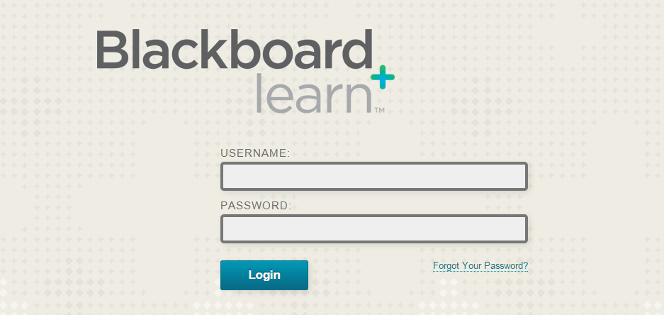

Step 2: From My Courses, select the course using Connect.
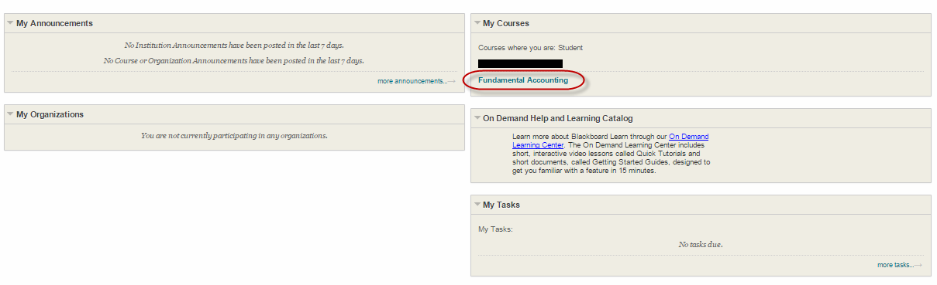

Step 3: On course homepage, click into the page where your instructor has posted the Connect assignments.
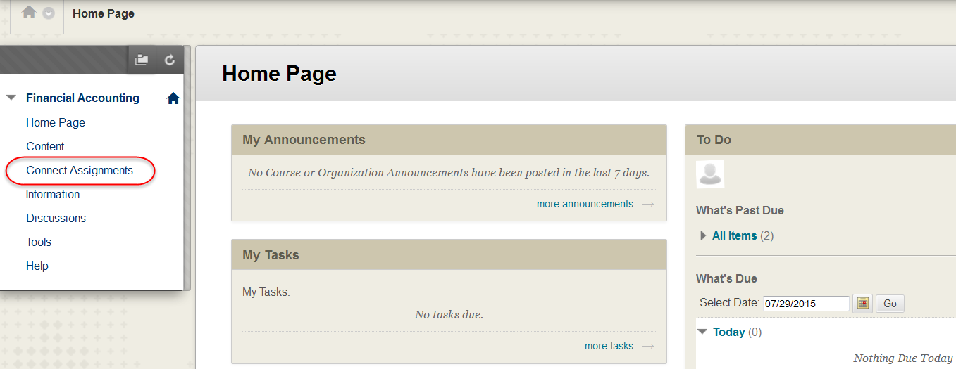
(In this example, the Connect Assignments page.)

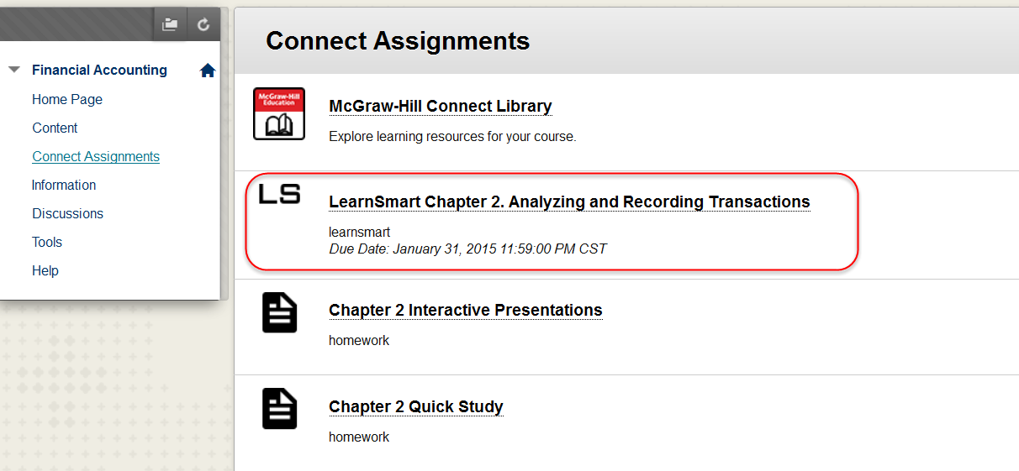
Step 4: Click on your first assignment (or the McGraw-Hill Connect Library link) to begin registration for Connect.

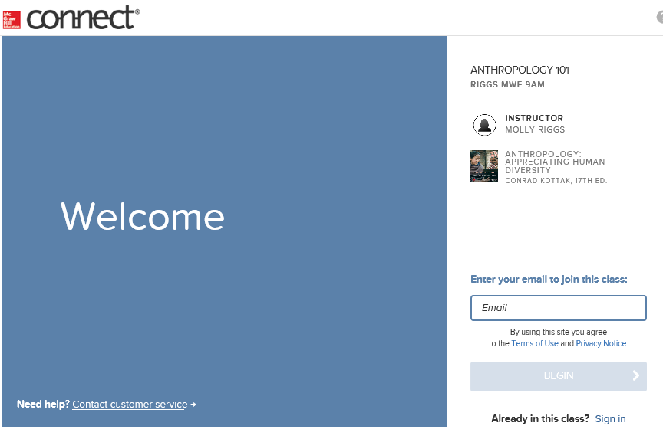
Step 5: Enter your email address and click Begin.

If you do not have a Connect account, you will be prompted to create an account.
We recommend using your school/institution email address when creating an account.

Click Next Step to continue.

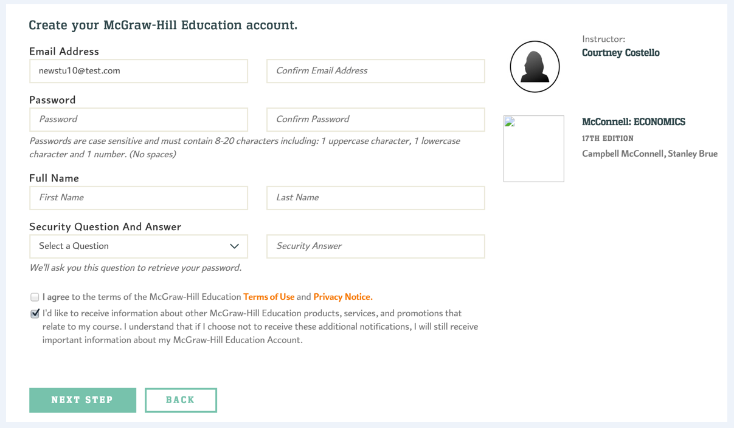

Step 6: You have three registration options.
- Connect Code: Enter Connect access code and click Redeem.
- Purchase Online: Click Buy It to use a credit card or PayPal.
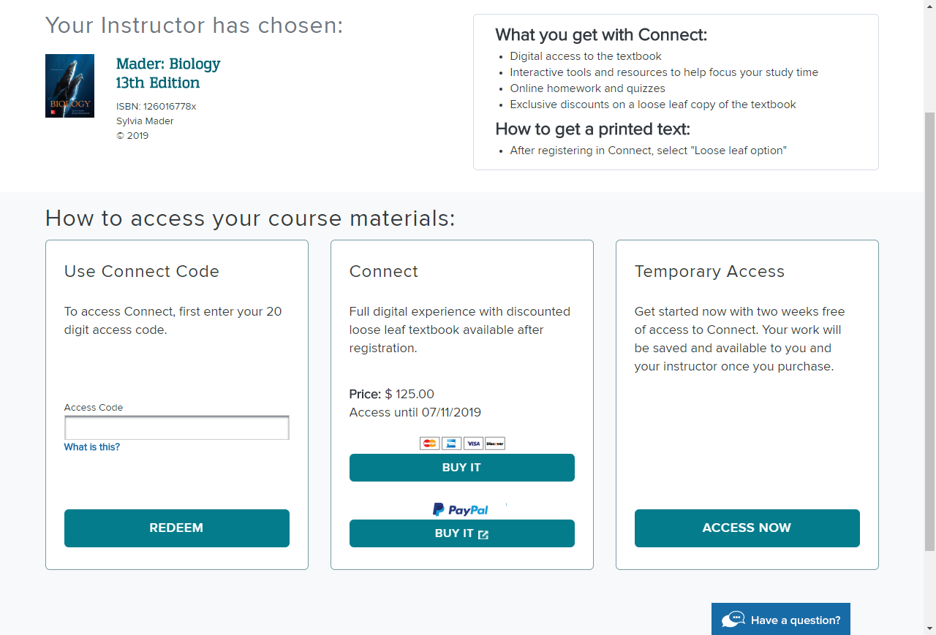
- Temporary Access: Click Access Now for two-week access.

New! For select McGraw-Hill texts, you can rent your course materials and get access to Connect, which can save you up to 30 percent as compared to purchasing your course materials and Connect separately.

Step 7: You have successfully joined the class. Click Go To Connect.

Need Help?
Tech Support & FAQ
Call: (800) 331-5094
Email & Chat: mhhe.com/support
Monday–Thursday: 24 hours
Friday: 12 a.m. – 9 p.m. EST
Saturday: 10 a.m. – 8 p.m. EST
Sunday: 12 p.m. –12 a.m. EST

